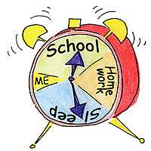

**This chart summarizes student/parent responsibilities for the week. It might be helpful to keep it posted until it becomes routine. Thanks bunches!**

|  |  |  |  |  |
| --- | --- | --- | --- | --- |
| **MONDAY** | **TUESDAY** | WEDNESDAY | THURSDAY | **FRIDAY** |
| • Initial Planner  • Check Folder  *(most tests will be returned on Mondays)*  • Spelling & Vocabulary Words Come Home | • Initial Planner  • Check Folder  • Reading Book Sent Home | • Initial Planner  • Check Folder  • Read Weekly Story  • **Gym Shoes Needed** | • Initial Planner  • Check Folder  • Read Weekly Story | • Initial Planner  • Check Folder  • Spelling, Comprehension, and Vocabulary Quizzes  • **Return Library Book** & Reading Book |

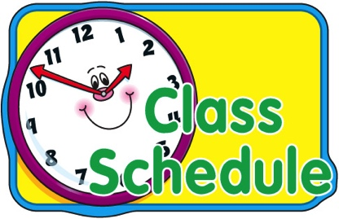

**Here are the times when students are out of the classroom for special classes. Where other teachers are listed, I am available for phone calls.**

|  |  |  |  |  |
| --- | --- | --- | --- | --- |
| **MONDAY** | **TUESDAY** | WEDNESDAY | THURSDAY | **FRIDAY** |
| Reading & Writing Block 9:15-11:55 | Reading & Writing Block 9:15-11:55 | Reading & Writing Block 9:15-11:55 | Reading & Writing Block 9:15-11:55 | Reading & Writing Block 9:15-11:55 |
|  | | | | |
| **Computer Lab**  1:45-2:15 |  | **Computer Lab**  1:45-2:15 |  |  |
| S.T.E.A.M. 2:50-3:40 | Music 2:50-3:40 | Gym 2:50-3:40 | **Technology Lab**  2:50-3:40 | Library & Media Lab 2:50-3:40 |